Pre-Kindergarten Supply List
Please label these items:
1 regular size backpack (no mini backpacks)
1 pair of Velcro or slip-on indoor shoes (no laces!)
1 full change of clothes in a ziplock bag
(with child’s name on the bag – pants, shirt, underwear, socks)
1 package of mini markers (pip squeaks)
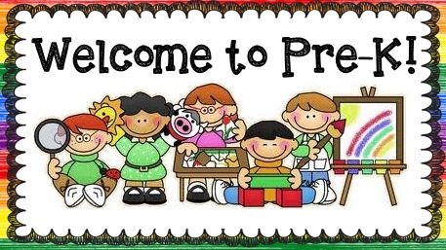
1 box kleenex

