Kindergarten Supply List
Needed Supplies:
1 backpack
1 water bottle that can be easily opened, filled, and closed without spilling.
1 pair of running shoes for indoor/gym use
**Velcro strap or slip on style** (NO LACES)
1 complete change of clothes labeled and put in larger Ziploc bag with child’s name on it.
1 family photo (email to elang@gscs.ca with your child’s name in the subject line)
1 package of golf pencils
1 pair of 5” blunt tip scissors
Appreciated Supplies
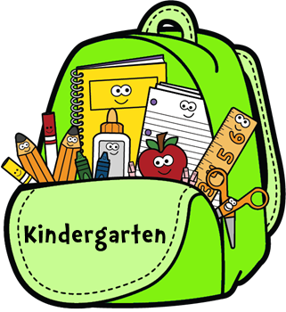
1 box of 24 Crayola crayons
1 pack of Crayola Pipsqueak markers
1 pack of mini dry erase markers
4 small Elmer or UHU glue sticks
1 large box of Kleenex
1 bottle of white glue
1 white eraser
1 package large Ziploc bags
1 pack of small Ziploc bags
Please choose 3 of the following:
- 1 pack of feathers
- 1 pack of foam stickers or
- 1 pack of beads
- 1 pack of pom poms
- 1 pack of googly eyes

