Invitation for Parents/Guardians to Edsby

Dear Parents/Guardians,
We are excited to share this invitation to Edsby with you. At this time, we are implementing the attendance, progress report and three-way/SPT conferencing aspects of the platform; however, there are many amazing features that we look forward to exploring further.

As you set up your parent account, your username will be your email address. Please ensure the school office coordinator has your current and correct email address and that the office coordinator has a unique email address for each parent/guardian.
Please note:
- Parents/guardians cannot share the same email address in Edsby
- If you are a GSCS employee, ensure the email address on file with your child’s school is a personal email address to eliminate challenges with logging in
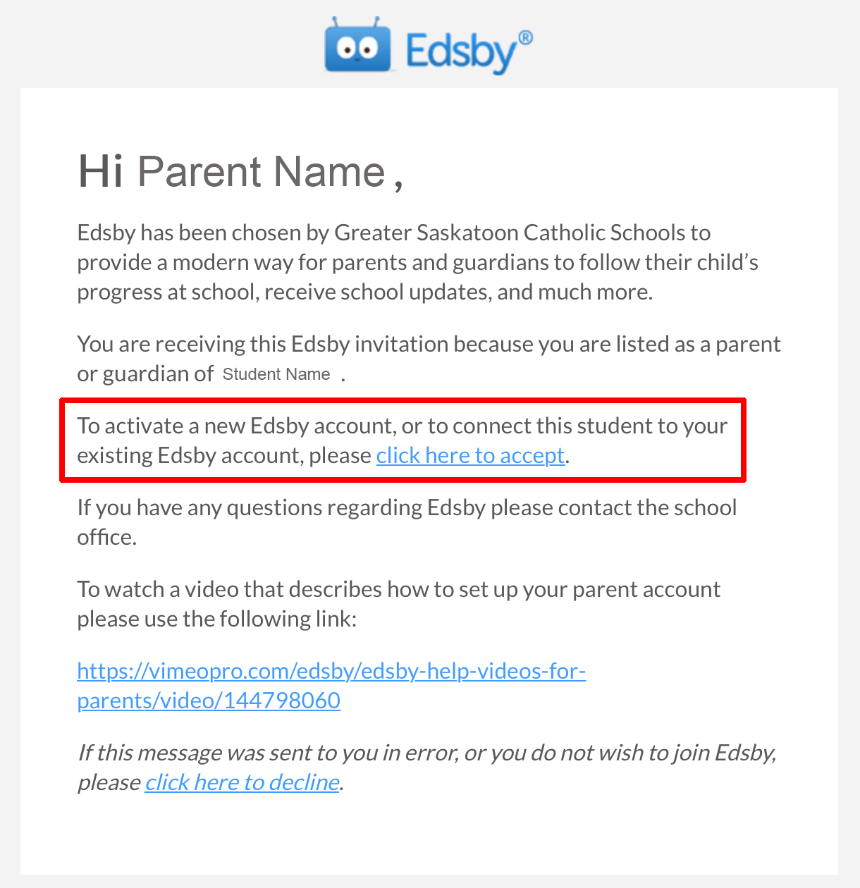

Below is information to set up your account. The auto generated password may be customized when you sign up. If you have more than one child attending our school or at one of our high schools, you can use the same information to log in and see information for all of your children.

Step 1: Create an Edsby account. You will receive an email from Edsby/GSCS with information to login in and create an account in Edsby. If you do not receive the invite today, please check your junk mail folder.

Step 2: Turn on Notifications. Edsby makes it easy to stay organized and up-to-date. Edsby enables various notifications to ensure parents are notified of the important things happening within the school. For more information, please click here. * You will need to be using a computer during set-up to enable notifications. If you would like to receive messages to your phone, you will need to ensure that push notifications for the Edsby app are enabled.
Step 3: Download the Mobile App. For more information, please click here.

We are now using Edsby for submitting absences, booking three-way/SPT conferences and accessing your child’s progress report.
Communicating Your Child’s Absence – Parents/guardians can easily submit an absence for their child using their smartphone and the Edsby app. For more information, please access the following video - Submitting a Planned Absence for Your Child
Booking Your Three-Way/SPT Conference – When it is time for three-way/SPT conferences, parents/guardians will receive the schedule in their Edsby mailbox. Parents/guardians can click through to the schedule and are able to schedule and easily change or remove bookings. For more information, please access the following video – Parent Teacher Interview for Parents
Viewing Your Child’s Progress Report Online – Once the school has submitted the progress reports online, parents/guardians will have access to view the report within Edsby. To view your child’s progress report, login to the Edsby web browser. Within the Classes panel – click View Report Cards. We will communicate with you when progress reports are ready for viewing in Edsby.
Frequently Asked Questions
Do I have to use a computer to use Edsby?
Edsby works in all browsers, iOS, and Android devices although you will need to use a computer to initially set up your notification preferences.

What is the server name when using the app?
GSCS

What is the URL when using a browser?
gscs.edsby.com

What is my username?
Your username will be the email address that you provided to the school office.

How will I know that I have been invited to Edsby?
You will receive an email to the email address you have provided the school for each child you have in the school. The invite is usually a bulk invite; therefore, it may go to your spam or junk mail.

Will I receive only one invite if I have more than one child in the school?
You will receive an invite for each child that is enrolled in the school.

Will I have more than one Edsby account if I have more than one child in school?
You only need one Edsby parent account, but will receive a separate email invitation for each child. Using the first invitation you will register for an Edsby account. You’ll then be prompted on a second screen to enter and confirm a password. Your email address and username will already be entered. Click Create Edsby Account. You’ll be logged into your Edsby Account and a “Welcome to Edsby” message will be sent to your email address. The information for at least one of your children will be immediately visible to you. For any other children, you will need to link to your existing Edsby account. To do this, find the Edsby invitation email(s) for your additional children. Click the link in the email, and then click Login to your existing Edsby account. Enter your Edsby username and password. Your existing Edsby account will now include the additional child.

What do I do if I forget my password? Where do I get help or support on how to use Edsby?
On the Edsby login screen there is a link for Can’t Log In. Click on this and enter your email address that you used when you registered for Edsby. An email will be sent with instructions to follow. Help is available here.

For your reference, this supporting document will be posted to the school website.

