Student/Parent Handbook

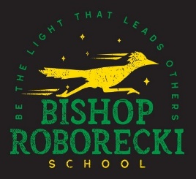

**2021-2022**

**Principal: Carol Sarich**

**Vice Principal: Curtis Howe**

**Office Coordinator: Elizabeth Glass**

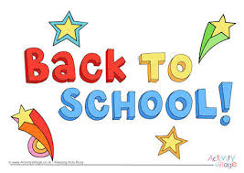 

**Administration Message**

******Welcome to the 2021-2022 school year. It is so wonderful to be back, and the staff looks forward to working with the students and families of the Bishop Roborecki community. School will look very different this year, but what will be the same is our focus on being a faith-based community, commitment to inclusive and academic excellence, and striving to “Be a Light that Leads Others!” We value the role of our collaborative relationships with parents and acknowledge that even though some practices will challenge us to do things differently in our educational environment, we are confident that we can be hopeful in our resilience to overcome all obstacles.

God Bless!

Mrs. Sarich: Principal

Mr. Howe: Vice Principal

**Bishop Roborecki Mission Statement**

**As a Catholic school, Bishop Roborecki is committed to making the Gospel values the central focus of all our endeavors. Working in partnership with members of our community, we will support each other on a life-long journey of learning, appreciating the unique spirit within each of us.**

*“* ***Be the Light that LEADS Others!***

|  |  |
| --- | --- |
| **Bishop Roborecki Staff 2021-2022**  Image result for roadrunner | |
|  |  |
| Sarich, Carol | Principal |
| Howe, Curtis | VP / LLI |
| Glass, Elizabeth | Office Coordinator |
| Bzdel, Natasha | Pre-K |
| Gratia, Angela | Kindergarten |
| Heagy, Stephanie | Grade 1 |
| Shulte, Janice | Grade 1/2 |
| Lakness, Natasha | Grade 2/3 |
| Sakowsky, Jenna | Grade 3 |
| Lyrette, Holly | Grade 4 |
| Hammer, Michelle | Grade 5 |
| Munroe, Carla | Grade 6 |
| Zerr, Keith | Grade 6/7 |
| Doepker, Brad | Grade 7 |
| Berzolla, James | Grade 7/8 |
| Pilot, Troy | Grade 8 |
| Seib, Amy | LAT |
| Dimen, Christine | LAT |
| Panamaroff, Tanya | LAT |
| Kindrachuk, Wade | EAL |
| Frantz, Debbie | Release |
| Wolitski-Conley, Candace | Release |
| Amyotte, Disa | ASAC |
| Itterman, Crystal | OT |
| Mudd, Gail | EA |
| Rupp, Terry | EA |
| Grant, Julie | EA |
| Arneson, Andrea | EA |
| Tarasoff, Lisa | EA |
| Lee, Jeannette | EA |
| Fizell, Darcy | EA |
| Martins, Adenike | EA (maternity leave) |
| Robichaud, Shelly | EA |
| Berg, Colette | Social Worker |
| Lieffers, Dianne | Speech & Lang. Pathologist |
| Courtney Cross | Nutrition Assistant |
| Soldat, Goran | Caretaker |
| James Hermez | Evening Caretaker |

**Mission Statement**

Greater Saskatoon Catholic Schools: a welcoming community where we nurture faith, encourage excellence in learning and inspire students to serve others, making the world a better place.

We love because He first loved us.

* John 4:19

Reaching Out. ….*to Transform the World*

**History of Bishop Roborecki**

Bishop Roborecki was born in the Velyki Mosty, Ukraine, on December 12, 1910. He came to attend the seminary in Toronto, Ontario. He was ordained in Winnipeg on July 18th, 1934.Canada with this family in 1913. He received his primary and secondary education in Winnipeg and

he first served the church in Dauphin, Manitoba and area. From there he went to St. Josaphat’s Parish in Toronto, where he stayed until 1948 when he was consecrated auxiliary Bishop of Winnipeg. In 1951 the Ukrainian Diocese of Central Canada was split into two separate diocese, Winnipeg and Saskatoon. On May 3rd, 1951 Bishop Roborecki was installed as the first Ukrainian Bishop of this new Eparchy for Saskatchewan at St. George’s Ukrainian Catholic Cathedral in Saskatoon. He served in this position until his death.

In honour of his achievements, the Saskatoon Catholic Board of Education named a school after him. Every year we will honour him in celebration on October 23rd.

**Bishop Roborecki Catholic School Community Council (CSCC)**

Bishop Roborecki School is very thankful to have an amazing Catholic School Community Council. This group is essential to having a successful school, as they serve as an advisory board for our school and are a voice for our school at the Board level. The CSCC contributes to many school projects, activities and events. They offer and sponsor special lunches and activities at school during the year and are integral in other spirit building and fundraising events for the school.

**Bishop Roborecki School Day Schedule**

9:00 a.m. Students meet at class line

9:10 a.m. Welcome Bell

9:15 a.m. Classes Begin

**10:15 – 10:30 a.m. Recess Cohort A**

**10:35 – 10:50 a.m. Recess Cohort B**

**12:00 p.m. Lunch**

12:40 p.m. Welcome Bell

12:45 p.m. Classes Begins

**2:00 – 2:15 p.m. Recess Cohort A**

**2:20 – 2:35 p.m. Recess Cohort B**

3:45 p.m. Dismissal

**Face Coverings**

A measure to further mitigate the risk of Covid 19 transmission is the use of masks.  Earlier this month our school division, along with many divisions across the province, mandated the use of masks for students in grades 4-8 in situations where physical distancing cannot be maintained.  Masks are recommended for pre-kindergarten – Grade 3 students when moving to and from rooms.

* Staff are required to wear masks when:
  + interacting with students, colleagues or visitors.
  + moving to and from rooms.
  + appropriate distancing cannot be maintained.
* Grade 4 – 8 students are required to wear masks when:
  + moving to and from rooms.
  + appropriate physical distancing cannot be maintained.
    - Masks are not required when students are in class, sitting and facing forward.
* All students are required to wear masks while riding the bus.
* All visitors must wear masks.
* Accommodations will be made for students and staff who are unable to wear a mask due to medical or other needs.
* Teaching will take place on mask usage. A helpful guideline link can be found at: <https://www.canada.ca/en/public-health/services/video/covid-19-wear-non-medical-mask-face-covering-properly.html>.  Please take time to review with your child(ren)
* Two reusable masks will be provided for each student should they require.  As mentioned, these will be handed out as students come into the school.

A reusable face shield and 3 reusable face masks have been purchased for each employee of our school division.

**Schedules**

* School day scheduling has changed to ensure our students stay within cohorts. We have designated two specific cohorts, Cohort A and Cohort B, which effectively divides the school population in half. The use of multiple entrances/exits in combination with the two cohorts is designed to support student entry and exit from the building in a safe manner. Our school recess and lunch schedules will be as follows:
* Our school has also determined specific plans to ensure the use of washrooms and water filling stations to allow for sanitizing and limiting student contact. Each classroom will be given a designated time for washroom breaks as well as opportunities to fill water bottles. Bathrooms will have external signs that will designate protocol for numbers of students allowed in a washroom at any given time. Also, cohorts will be assigned bathrooms and water stations nearest to those classrooms. Of course, students will be allowed to use the bathrooms during the day, as needed, but will have to abide by the numbers allowed in the facility.

**Lunch**

* If possible, students should return home to eat lunch. If students must eat lunch at school, they will eat in their classrooms. Strict cleaning protocols will be observed. Students who stay for lunch will be responsible to bring everything that they require in containers that they are able to open, and to bring
* home any leftover food, containers and recyclables. Students are reminded not to share any food items with others.
* School lunch time is from 12:00 to 12:40. Like recess, we will have students be part of cohorts for the lunch time. One group (Cohort A) will eat lunch first from 12:00 to 12:20 and then go out for recess from 12:25 to 12:40. The second group, (Cohort B) will go out for recess first from 12:00 – 12:15 and eat their lunch from 12:20 to 12:40. This is a change of practice, but is necessary to support giving all students a chance for a lunch recess.
* Students should come to school with a prepared lunch as outside services are not allowed in the school (ie, Skip the Dishes, deliveries)

Food sharing practices will not be permitted; please keep this in mind as we will not allow sharing of birthday treats, pizza parties, etc

* Students should come to school dressed appropriately to go outside during recesses.
* Indoor recesses will be announced by a staff member if it is raining or the temperature reaches -25C with the wind chill.Areas outside school boundaries are out of bounds during noon and recess breaks. Students may eat snacks outside during recess, but are expected to dispose their trash in the garbage cans provided

We are pleased to offer the students the privilege of remaining at school for lunch. To ensure a happy, safe, and fair environment, the following rules will apply:

Students staying for lunch will be accountable to noon-hour supervisors.

Students must remain seated in their classroom while eating or drinking. Students are in their classrooms from 12:00 to 12:20 and go outside for the remainder of the lunchbreak.

Students are not allowed to leave the school grounds unless they usually go home to eat lunch or unless they have written permission from a parent or guardian.

**Nutrition Programs**

* Students will continue to access nutrition support with the provision of breakfast, snacks and lunch in schools with nutrition programs. New food preparation and distribution guidelines have been put in place to mitigate risks associated with exposure to communicable diseases. Nutrition workers will adhere to strict sanitization procedures and protocols. In addition, access to kitchens will be limited and those involved in food preparation and all those who access the kitchen will wear personal protective equipment. Food will be covered while it is being stored and when it is delivered to classrooms. All food will be in individual sealed containers and will be distributed by staff wearing masks and gloves. Food service dishes will be collected by staff and will be sterilized in an industrial dishwasher.

**School Partners**

* Our school has the Boys and Girls Before and After School Program that operate within our building. The school administration has met with this partner to review GSCS safety protocols. The program will continue to use the Arts and Science room. Parents/Guardians will drop off/pick up their children at the entrance in the parking lot.

1) Parents/caregivers are required to leave an emergency number if a child needs to be picked up from the school.

2) Students will be asked daily to share how they are feeling and responses to the Covid-19 Screening Questionnaire (please see a copy of the questionnaire at the end of this package). Please support our ability to keep our school building safe by making this questionnaire part of your morning conversations.

3)  **If a child is ill, they are not to be coming to school.** Please report all absences through Safe Arrival. If a child becomes sick during the school day, they will be accompanied to the Comfort room. Parents/caregivers will be called to have the child picked up. A call will be made to public health. This needs to be done as soon as known that a person is ill. Doing this will help SHA keep track of any possible contact tracing should a student test positive for the virus.

4) A big part of our role during the first weeks of school will be the teaching and reinforcement of cleaning and social distancing practices. Wearing face masks and frequent washing of hands is important for keeping the transmission of this virus to a minimum. Upon entering the school and classrooms, student will be required to sanitize their hands. Movement in hallways will be restricted to cohort groups.

5) As part of our Health and Safety plan, **only school personnel and students will be allowed in our school.**  This is to ensure contract tracing methods can be followed.

**Health and Safety of our School Community**

The health and safety of our students and staff is of utmost importance. Greater Saskatoon Catholic Schools (GSCS) and the Medical Health Officers (MHO) have collaborated on a plan to facilitate communication to report and track ill individuals and establish protocols in the event of a positive Covid-19 case identified within our schools. The following procedures all support both our schools and the SHA:

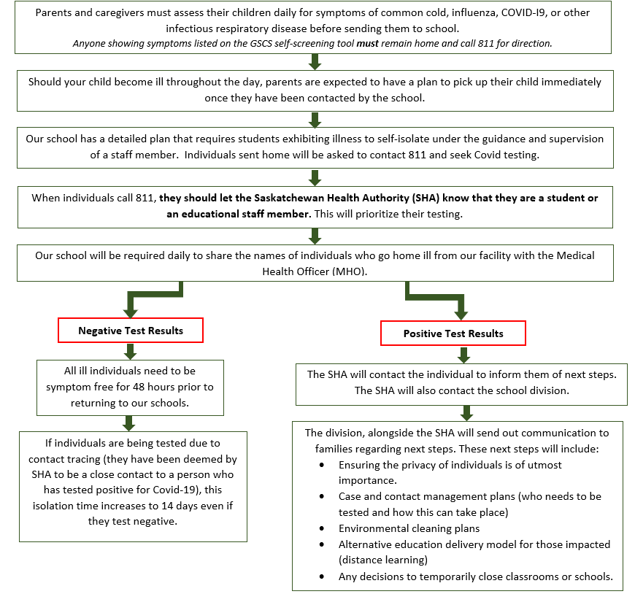

**THE 7 HABITS**

Since 2011, Bishop Roborecki School staff and students have embraced The Leader In Me program. The 7 Habits is a set of leadership and life skills from Stephen Covey’s book The 7 Habits of Highly Effective People. A quick overview of the habits follows:

**Habit 1 - Be Proactive: You’re in Charge**

I am responsible person. I take initiative. I choose my actions, attitudes, and moods. I do not blame others for my wrong actions. I do the right thing without being asked, even when no one is looking.

**Habit 2 – Begin with the End in Mind: Have a Plan**

I plan ahead and set goals. I do things that have meaning and make a difference. I am an important part of my classroom and contribute to my school’s mission and vision. I look for ways to be a good citizen.

**Habit 3 – Put First Things First: Work First, Then Play**

I spend my time on things that are most important. This means I say no to things I know I should not do. I set priorities, make a schedule, and follow my plan. I am disciplined and organized.

**Habit 4 – Think Win-Win: Everyone Can Win**

I balance courage for getting what I want with consideration for what others want. I make deposits in others’ Emotional Bank Accounts (Bucket Filling). When conflicts arise, I look for third alternatives.

**Habit 5 – Seek First to Understand, Then to Be Understood: Listen Before You Talk**

I listen to other people’s ideas and feelings, I try to see things form their viewpoints. I listen to others without interrupting. I am confident in voicing my ideas. I look people in the eyes when talking.

**Habit 6 – Synergize: Together Is Better**

I value other people’s strengths and learn from them. I get along well with others, even people who are different than me. I work well in groups. I seek out other people’s ideas to solve problems because I know that by teaming with others we can create better solutions than anyone of us can alone. I am humble.

**Habit 7 – Sharpen The Saw: Balance Feels Best**

I take care of my body by eating right, exercising and getting sleep. I spend time with family and friends. I learn in lots of ways and lots of places, not just at school. I find meaningful ways to help others.

Our staff has made the commitment to model and implement the 7 Habits of Highly Effective People at our school, in order to provide a caring and nurturing learning environment for our students. Teaching students and developing leaders is what we do! Through the teaching of the 7 habits, our staff is working together with students to create a school that maintains the dignity of children through productive interactions while fostering a positive relationship with parents and other community members.

 

**STUDENT'S RIGHTS AND RESPONSIBILITIES**

The following rights and responsibilities have been established to ensure that each student is valued and has the opportunity to learn in a safe, positive environment.

1. I have a RIGHT to learn in this school. It is my RESPONSIBILITY to work to the best of my ability and not disrupt another’s right to learn.

2. I have a RIGHT to hear and be heard. It is my RESPONSIBILITY not to disrupt when others are speaking.

3. I have a RIGHT to be respected in this school. It is my RESPONSIBILITY to be a positive role-model for others.

4. I have a RIGHT to be safe in this school. It is my RESPONSIBILITY not to threaten or physically harm others.

5. I have a RIGHT to privacy and to my own personal space in this school. It is my RESPONSIBILITY to respect the privacy and personal belongings of others.

**RELIGION & LITURGICAL CELEBRATIONS**

We are a Catholic school and offer religious and liturgical celebrations throughout the year.

All students will participate in the Catholic Religion Program. Students are expected to show respect and reverence at all times through contemplative silence and appropriate participation.

**SCHOOL HOURS**

First bell at 9:10 a.m. Classes begin at 9:15 a.m. Dismissal at 3:45 p.m. Students are asked to arrive no earlier than 9:00 a.m. except those in Before and After programming.

We ask that students do NOT arrive at school earlier than 9:00 a.m. unless they are registered and attending the Before School Program.  The school cannot provide supervision earlier than 9:00 a.m. and exterior doors will remain locked until this time.  If this creates any undo challenges for families, please contact Mrs. Sarich – Principal to discuss the situation.



**SCHOOL ATTENDANCE**

Regular and punctual attendance is necessary to achieve the best results in their schoolwork.

If a student is going to be absent or late, parents are asked to notify the school before 9:00 a.m. by using the Safe Arrival App. This service is available 24 hours a day.

If we have not received notification of an absent or late student, you will be contacted shortly after 9:30 a.m. This is a safety precaution to verify the whereabouts of your child and to ensure his/her well being. If your child will be late or coming from an appointment; it is extremely important to stop at the front office to pick up a late slip. This is so all students can be accounted for and we know they are in the school.

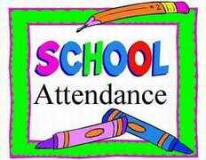 **Safe Arrival** 

**You have three convenient ways to report absences, and you can report planned absences in advance.**

1. On your mobile device, download and install the **SchoolMessenger** app from the Apple App Store or the Google Play Store (or from the links at <http://go.schoolmessenger.com>). The first time you use the app, select Sign Up to create your account. Select Attendance then Report and Absence.
2. Use the SafeArrival website, <https://go.schoolmessenger.com>. The first time you use the website, select Sign Up to create your account. Select Attendance then Report an Absence.
3. Call the toll-free number 844-425-7221 to report and absence using the automated phone system.

If there is an unreported absence, parents/guardians will be contacted via the SchoolMessenger Communicate automated notification system. The automated notification system will attempt to contact parents at multiple contact points until a reason is submitted for the absence. If our system is unable to reach the designated contacts, office staff will follow up.

**COMMUNICATION**

Communication is a big part of our daily lives. It is important to Staff, Student and Parents to always keep the lines of communications going. Daily communication planners, notes sent home and newsletters keep the communication active in our daily lives. If you have any questions in regard to anything; feel free to contact the office at any time. 306-659-7180.

For attendance and/or office communication, emails will come from [broadcasts@schoolmessengermail.com](mailto:broadcasts@schoolmessengermail.com). Please ensure you have this email address on your approved sender list, so it won’t be filed as junk or spam.

**Newsletters** will be sent every other Tuesday. We encourage paperless delivery, limiting hard copies in support of health measures.

**PROGRESS REPORTS**

There will be three formal reporting periods during the year: November, March and June. However, parents are encouraged to contact teachers as needs arise. Parents are expected to book parent/student/teacher conferences in November and in March; however, conferences will be done online or by phone.

**TELEPHONE USE**

Telephones in the school are important communication links between the school and home.

Students may use the telephone when granted permission by a staff member.

**MOBILE DEVICE POLICY**

Mobile devices are not to be used in hallways at any time or during recess and noon lunch times, while at school. Devices may be used for specific communication with parents/caregivers if a staff member grants permission. The teacher of a class may also allow students to use devices in that class with specific permission. Reasons may include research, interaction or other uses, as designated by the staff member. Mobile devices not needed for any of the above reasons should be left at home. Should it be necessary to bring a device to school, it must be stored safely in backpacks or bags, or can be securely stored at the Main Office until the end of the day.   Students bring mobile devices at their own risk.

**AN ALLERGY ALERT ENVIRONMENT**

Bishop Roborecki School is committed to providing a safe and positive environment for all students, parents and staff. In order to meet this objective, we have designated ourselves “An Allergy Alert Environment". Several students attending our school have extremely serious, life-threatening allergies to various nuts and nut by-products, as well as eggs, milk, food dye, colognes, perfumes and animals.

* Please avoid sending nuts or nut by-products to school.

* Please be aware that the residue from nuts or nut by-products may also trigger severe allergic reactions.

* Please refrain from wearing perfumed products while at school.

* Please refrain from bringing pets to school unless it is for a special occasion such as ‘Show and Tell’, and it has been cleared with the classroom teacher ahead of time.

We appreciate your awareness and sensitivity to these issues.

**DRESS EXPECTATIONS**

* All students are expected to dress appropriately throughout the year. We ask that all students choose clothing that allows them to participate in school activities and do not compromise or distract the learning environment:
  + Tops should be modest: midriffs should not be showing. Students are asked not to wear halter tops, tube tops or spaghetti straps. Lasagna-wide straps only.
  + Clothing should convey a positive lifestyle: slogans and/or pictures promote positive expressions.
  + Students are allowed to wear shorts or skirts that are mid-thigh or longer.
  + Hats, toques, and hoods are not to be worn inside the building.
  + Students are asked to have footwear.
  + Students should have a pair of gym shoes for indoor wear.

Students wearing inappropriate clothing can expect a staff member to immediately ask them to cover the garment in question or replace it with an article of clothing that is appropriate.

**INTERNET ACCEPTABLE USE POLICY**

We acknowledge that in this information age students need the opportunity to access, evaluate and produce information. The Internet can be a valuable resource to this end. Access to the Internet, however, is a privilege, not a right. It is a general expectation that Internet use will be in accordance with the mission statement of the Greater Saskatoon Catholic Schools.

Internet use is in many ways analogous to a trip outside of the school. Access to the Internet will thus be supervised by a teacher and granted at the teacher’s discretion for specific educational goals. Students will not assume free Internet access whenever they are working at a computer. It is acknowledged, however, that one-on-one supervision will not always be possible, and students are expected to act responsibly. Internet use outside of class time will be available for special projects with teacher supervision only. All students will review Acceptable Use Policy.

**ANTI-BULLYING POLICY**

Bishop Roborecki will not tolerate bullying behavior. Guided by our Gospel values and our Code of Conduct, bullying behavior will be dealt with in a serious and timely manner. Bishop Roborecki believes that all students have the right to a safe, caring and respectful school environment. Students also have the responsibility, by their actions, to ensure that everyone is in a safe caring and respectful learning environment.

**DEFINITION OF BULLYING**

A student is bullied when he or she is repeatedly exposed to negative actions on the part of one or more students causing emotional, psychological and/or physical harm. These negative actions are intentional and hurtful. Bullying can be verbal, physical, relational or reactive and includes cyber bullying. Bullying involves an imbalance of power, creates fear and is not gender specific.

**ROLES AND RESPONSIBILITES** 

The effectiveness of this policy will depend on the level of open and honest communication between everyone involved. In addition to the expectations outlined in the School Code of conduct:

Bishop Roborecki School students expected to:

* + be positive and caring role models
  + refrain from bullying or being bystanders to acts of bullying
  + be active participants in school anti-bullying initiatives
  + report acts of bullying to appropriate school personnel, parents/guardians

Bishop Roborecki Staff are expected to:

* + Provide stewardship that uphold the Gospel values and promotes positive relationship between students, staff and parents/guardians.
  + Address bullying in an age appropriate manner
  + Implement the schools anti bullying initiatives in conjunction with our School Code of Conduct
  + Investigate reports of bullying, apply interventions and follow-up
  + Keep lines of communications open between the home and the school
  + Encourage and teach students to report incidences of bullying

Parents/Guardians, Parish and Community Members are expected to:

* + Be active contributors to a safe, positive, caring, and respectful school community
  + Learn about bullying behavior and related issues
  + Inform the school if bullying is suspected
  + Work with the school to resolve identified incidents of bullying

**Procedures** 

1. Prevention - Prevention of bullying is the goal. Strategies are ongoing and include the use of our own Code of Conduct with conjunction with social skills programs, Lion Quest and skills for adolescence programs, classroom rules, open communication and common language.
2. Investigation – The safety of all student is always the primary focus. Students involved shall be spoken to and dealt with individually using age appropriate interventions. Information shall be gathered from all students involved. An STP from may be completed. A bullying Incident Report may be completed.
3. Actions If Bullying Occurs –
   1. Actions shall take into account.
      * The safety of all students is always primary focus.
      * Age and maturity levels of students.
      * Level of harm that occurred – be it physical, emotional, mental.
      * Similar related incidents in the past and/or continuing patterns of behavior
      * Follow-up for all those involved
      * Classroom teacher or in-school administrator determine whether parents/guardians need to be informed
      * Student services personnel may be called for assistance
      * Intentionally and falsely accusing another student of bullying shall be considered bullying behavior
      * Consequences may include:
        + Discussion, problem solving, reviewing behavioral expectations
        + Loss of privileges, detention, reprimand, action plan
        + STP Form (Stop, Think and Plan Form)
        + Removal from class, suspensions, expulsions
        + Referral to Student Services
        + Restitution, Community services, counseling
        + Behavioral contract
        + Alternative programing, alternative placement, community agencies
   2. A student may be suspended for such behavior as:
      * Intimidation, harassment or any other behavior that threatens students, staff, parents/guardians, or other members of the community
      * Possession of illegal drugs or alcohol
      * Theft or damage to school or others property
      * Intentional opposition to authority
      * Bullying behavior
   3. If bullying behaviors is part of a continuing pattern:
      * In School administrators or designate shall complete a Bullying Incident Report
      * Parents/Guardians of those students involved will be invited to meetings to discuss child’s involvement in incident(s). In most cases thee will be separate meetings
      * A written record shall be kept of the plan of action. This record shall be held in a confidential file by the principal or designate and reviewed annually.

**FIRE DRILLS/LOCKDOWNS AND EVACUATION**

Bishop Roborecki School takes every precaution to ensure student safety in case of emergency. Fire drills and lockdown practices randomly occur throughout the year.

[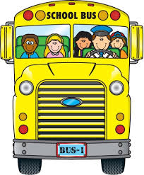](https://www.google.ca/url?sa=i&rct=j&q=&esrc=s&source=images&cd=&cad=rja&uact=8&ved=0ahUKEwjXpPPS3evWAhVmwYMKHW9BDkYQjRwIBw&url=https://cliparts.zone/bus-chair-cliparts&psig=AOvVaw05uZmebMRkiRoo5soXr6n9&ust=1507919901702666)

**IMPORTANT!** 

In order to keep our students and school community members safe, please:

**DO NOT Block the alley by staff parking lot, drop students off or park in the staff parking lot.**

**DO NOT Make U-Turns**

**DO NOT Park in the bus or handicap zones**

**Thank you for supporting our efforts to keep our children safe!**

**BUS INFORMATION**

MC900134537[1]**First Student Bus Hot Line – 306-343-3300. Please feel free to phone this number anytime there is severe weather, and check if your child’s bus is running.**

* Expectations for student behavior and conduct apply during all bus travel.

**Bus delays or cancellations**

**First Student:**

For up to date information call **(306) 343-2125** or visit <https://saskatoon.firststudentinc.com/cancellations.aspx>, where you can also subscribe to email updates or subscribe to their RSS feed.

**BICYCLES, SKATEBOARDS AND SCOOTERS**

Bishop Roborecki School assumes no responsibility for bicycles, skateboards, scooters or longboards lost or damaged while on school premises. All bicycles should be parked in the bike area and should be locked. Bicycles, skateboards, roller blades, long boards, scooters, & shoes with wheels are not to be used on the playground.