|  |
| --- |
| **St. Frances Cree Bilingual School**  **2141 McPherson Ave** [**gscs.ca**](http://www.scs.sk.ca/fra) **6 Bateman Crescent**  **306-659-7310 306-659-7940**  **Pre-K to Grade 5 Grades 6 to 9**  **Principal: Lori McAuley**  **Principal (Bateman): Lori McAuley**  **Vice Principal: Mr. Barry Kimbley**  **Vice Principal: Mr. Josh Klein**  **Office Coordinator/Secretaries: Joan Marcotte, Mrs. Sherry McEachern, Mrs. Ngozi Nwokeji**  **School Board Trustees (Liaisons): B. Elliott November 1, 2023** |

|  |
| --- |
| DATES TO REMEMBER:  Oct. 16th-Nov. 30th Beading program over the noon hour Mon.-Thurs. for 6 weeks  November 7th Drum Group-every Tuesday at McPherson until December 19th.  November 9th Remembrance Day Liturgy at each campus  November 10th PLD no school for students  November 11th Remembrance Day  November 13th Remembrance Day observed No School for students and staff  November 23rd Pay Day Play Day at Bateman from 5:00-7:00pm  November 23rd 3 Way Conferences (pm) 3:45-8:00pm  November 24th 3 Way Conferences No School 9:00am-1:00pm  November 27th Reports Cards  December 4th Advent Liturgy at each campus  December 22nd Students last day before Christmas break  December 23rd Christmas break  January 8th Students First Day back from break  January 22nd PLD No school for students  February 14th Valentines Day  February 19th Family Day-no school  February 20-23rd School Break- no school  March 4th PLD-no school for students  March 21st 3:30-8:00pm Three Way Conferences  March 22nd 8:30-12:30pm Three Way Conferences  March 25th Report Cards sent home  March 29th Good Friday- no school  March 31st Easter Sunday  March 1-5th Easter break |

**Principal’s Message**

It is hard to believe it is November. We will be hosting our 3 Way Conferences on November 23rd and 24th, we hope to see you then. We will have some gift card raffles and Saskatoon Tribal Council will be providing an information session on resources and supports available to the community. If you are unable to make it out, please book a time with your child’s teacher to meet on any other day. Progress reports will be sent home on November 27th. If you have any questions or concerns regarding your child’s assessments, please do no hesitate to contact the teachers.

Thank you for your support! As parents and guardians, you are the primary caregivers of your children. We encourage communication and value the relationship we have with you so that we can work together to create a positive learning experience for your child. Don’t hesitate at any time to reach out to us for any reason.

As a school that celebrates both the Gospel Virtues of the Catholic Faith, as well as the Tipi teachings of the First Nations Community…we are celebrating the Virtue and Tipi Teaching of ***Kinship & Community*** this month.

**Education Week- October 16-20, 2023**

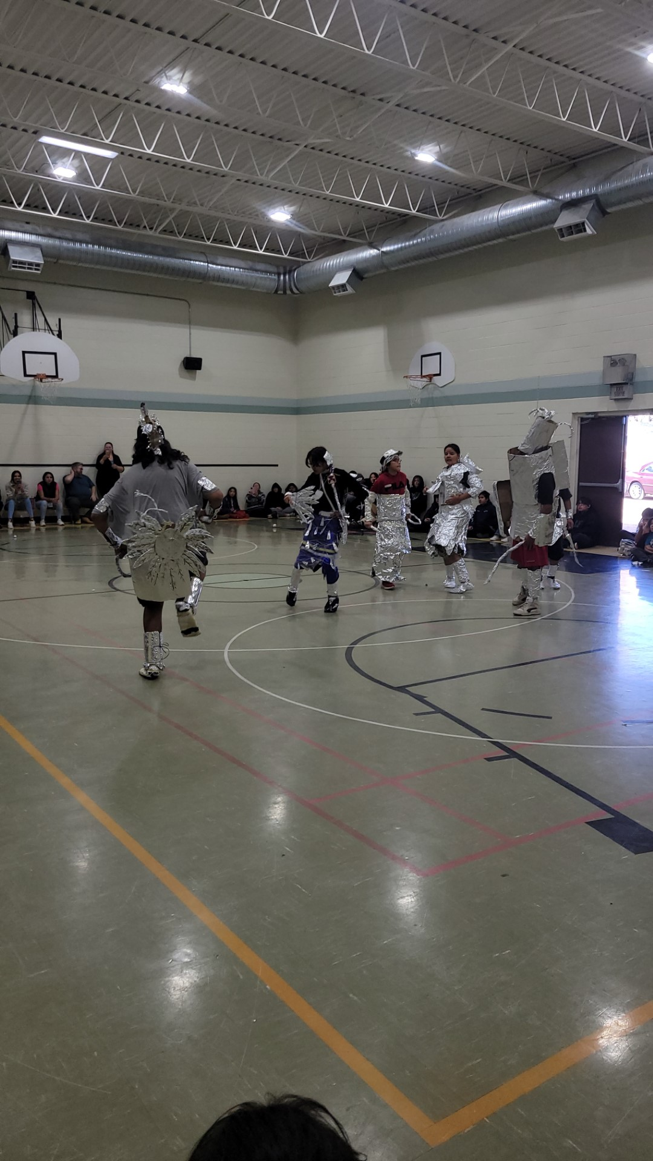

Bateman students wrapped up Education week activities with a tinfoil special where each classroom got a roll of tinfoil to create regalia on one classroom representative. The winner was chosen by loudest cheer after dancing for the school. Thank you to all who participated!  Cole Gardipy won the tinfoil special thank you admin for donating the prizes of candy for the grade 9 class.

Education week activities included:

**peyakokisikaw Monday** Jump up and get down relay; Grade 7/8 Ms. Fineblanket

**nisokiskikaw Tuesday** Tic Tac Toe; Teachers won against Grade 7 Mrs. Roberts

**nistokisikaw Wednesday** Garbage bag fill up; Grade 8 Ms. ReganTug of War

Grade 7/8 Ms. Fineblanket

**newokisikaw Thursday** All students enjoyed a movie with free popcorn thanks to ISAC-Mr. Peeteetuce

**niyanankisikaw Friday**Tinfoil Special;Grade 9 Mr. Bird and Ms. Lafond

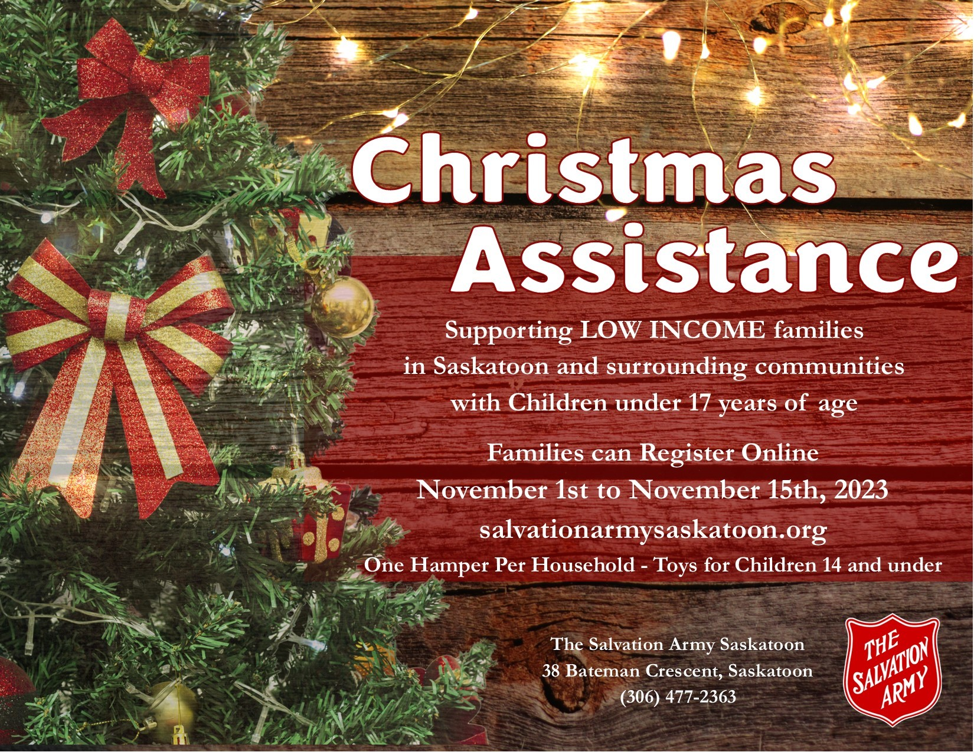

***The St. Frances Choir***

The St. Frances choir already sound and look beautiful when they sing songs in English, Cree and even sign language!  Students in grades 2-5 are welcome to participate in weekly choir practices in the library at noon.  Students who attend regularly will have the opportunity to participate in various performances throughout the year.  More information about performances will be shared closer to events.  A big thank you goes out to the long-time volunteer choir leaders from Cornerstone church.

***Nehiyew Coding Club***

October 26th, is the start date, it will be every Thursday for six weeks.

We will play with circuits and learn how to build simple circuits.

We will play with robots and learn how to code them.

We will learn how to create our very own video game.

***Dance Troupe***

**Practice**: They will be practicing at lunch on Tuesdays and Thursdays. Mr. Peeteetuce will be sending consent forms home this week. Please watch for the consent forms and send them back filled out and signed if you want your child performing with the dance troupe.

**Upcoming presentations for Dance Troupe**

Beardy’s-TBA

MyHumanitas-TBA

St. Dominic-TBA

St. John-November 1st

Wanuskewin- November 18th

Wanuskewin- December 2nd

Wanuskewin-December 9th

Ahtakakoop-TBA

Wanuskewin-Saturdays (January-June)

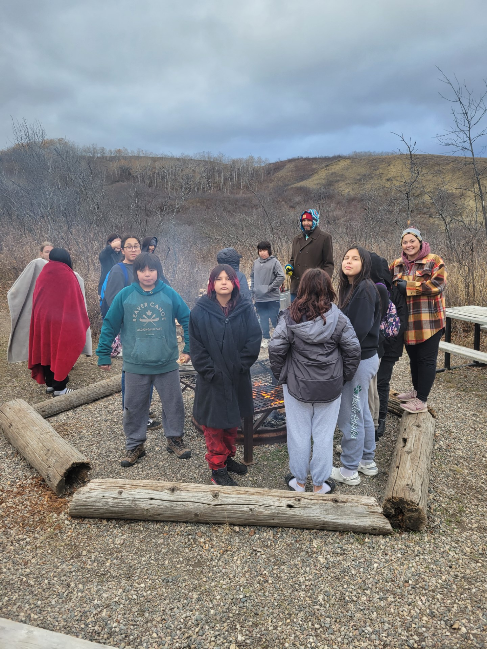

On Oct. 23 Grade 7/8 Fineblanket went to Eagle Creek with Kelley Fineday and Mooshom John. We smudged and prayed, and proceeded to do a 2.5 km hike. We saw a beaver dam, natural springs, buffalo sage, horse sage, juniper, and thunderbird medicine. It was a rich day of learning; we worked on a moose hide. We then decided to let the students have some time to play double ball. The students had a wiener roast, and roasted marshmallows. Thanks to Ms Fineblanket for bringing the supplies.

Classroom excursions are a great incentive to get work completed and build classroom motivation. The next class trips are Nov. 3 Lakewood Civic Center for Swimming, and Nov. 9 Remai Art Gallery. Happy takwakin!

**Jordan’s Principle**

Saskatoon Tribal Council has had an overwhelming request for accessing Jordan’s principle, they launched a toll-free number to support families with this process. The number is 833-355-5501.

***Pay Day Play Day***

We have our partners who will be supporting a pay day play day on November 23rd. The evening will start with supper and then the families will be welcomed into the gym to play some numeracy games. Some of the games will be making a duct tape wallet, Tic Tac Take…. Your Money to the Bank. We will have draws throughout the evening. We invite all our St. Frances Community to come out and have fun with your families.

**Lockdown Practice**

Our next lockdown practice will be December 5th and a perimeter lockdown practice the following week.

**Reporting and Self-isolation**

• Reporting of positive COVID-19 cases is not required.

• Please report all absences through Edsby.

**BUS/TRANSPORTATION**

First Student will continue to drive students to and from school and transfer grades 6 to 9 students to St. Frances Bateman. Students provided with transportation will be expected to cooperate in a respectful and safe manner to and from school. Please call the school if you have questions regarding rules and regulations. **If you are picking up your child after school and they normally take the bus home, please have a written note to give to the teacher**. If you have a concern with bussing, please feel free to contact First Student directly at (306)343-2125 or late bus inquiry at 343-3300.

There is also an app you can download to track your child’s bus**. FirstView Bus Tracking**, the new code for St Frances on **McPherson is KC5F, for Bateman it is PRGA**.

**REPORTING A STUDENT ABSENCE Using Edsby**

We are now using Edsby for submitting absences, booking three-way/SPT conferences and accessing your child’s progress report.

Parents/guardians can easily submit an absence for their child using their smartphone and the Edsby app.

If you did not receive your invitation to Edsby please call the school.

**St. Frances McPherson (Pre-K-Gr. 5) School Day Hours**

8:55 School Begins

10:15 Gr. 3-5 Recess

10:30 K-2 Recess

11:45 Lunch hour

11:45-12:05: K-Gr.3 students eating; Gr.3-5 students outside

12:05-12:25: K-Gr.3 students outside; Gr. 3-5 students eating

12:30 Classes resume

2:00 K-2 Recess

2:15 Gr. 3-5 Recess

3:25 Dismissal

**St. Frances Bateman (Gr. 6-9) School Day Hours**

9:05am School Begins

10:35am Recess Bell

10:45am Bell to Resume Class

11:30am Lunch

12:00pm Bell to Resume Class

1:30pm Recess

1:40pm Bell to Resume Class

3:10pm Dismissal (Students board transfer buses back to St. Frances McPherson and then home)

**Student Expectations**

Our school expectation for all students and staff is Miyo-Pimohtewin, meaning “walking in a good way”.

***Definition of bullying***: A student is bullied when he or she is *repeatedly* exposed to negative actions on the part of one or more students causing emotional, psychological, and/or physical harm. These negative actions are intentional and hurtful. Bullying can be verbal, physical, electronic/on-line, relational, and reactive. Bullying involves an *imbalance of power, creates fear,* and *is not gender specific*. As a school, we work with parents/caregivers to ensure each reported incident of bullying is addressed with appropriate consequences and accompanying teaching strategies to support the instigators of bullying.

***Definition of conflict:*** Conflict is a disagreement or a difference of opinion or interests *between equals*. The people involved in a conflict may disagree vehemently and emotions may run high. When conflict is badly managed, it may result in aggression. In a conflict, *both parties have power* to influence the situation. That is their goal.

Please report any incidences of conflict or bullying to the school if your child reports any such incidences to you at home. It is not always seen by adults in the building, your help and cooperation are greatly appreciated to ensure the safety of all students.

**NOON LUNCH**

Students have the privilege of eating lunch at school when it is not possible to go home. This year we will continue to eat in our classrooms. All lunchroom expectations continue, including: remain in their classrooms during the eating portion of the lunch time, clean up after themselves, and be respectful. Supervision will be provided during the noon lunch hour. If you are dropping off lunch for your child(ren) please check in at the main office first and Joan, Sherry, or Ngozi will call your child(ren) down to pick it up, or you can drop it off at their classroom.

**MICROWAVES**

Please do not send microwaveable food with your child for lunch or snacks. Microwaves are not available for student use. Thanks for your understanding and cooperation. If you have any questions or concerns then feel free to contact the school.

**STUDENT ALLERGIES**

Please remember that we strive to be a nut free school. We have many students with nut allergies and want to ensure they are in a safe environment at school.

**LEAVING THE SCHOOL GROUNDS AT LUNCH**

For safety reasons, all students who stay for lunch are to remain on school property during the entire lunch hour. Students are not permitted to leave to go to a friend’s house or to the store during this time unless a parent/caregiver picks up their child from school to take them there. Thank you for your support and understanding. Keeping our students safe is our number one priority!

**SCHOOL ZONES/PARKING**

Please be reminded of the new reduced speed zones, 30km/h in school and park zones every day from 7:00am to 7:00 pm. The few extra seconds can save a child from serious injury. As well, please avoid parking in the school bus or special needs (handicapped) loading zones. Vehicles in these zones will be ticketed. There are 22 busses dropping off and picking up students and arrive at the school at 8:45am and 3:00pm Monday-Friday. Thank you for your cooperation and understanding.

**PROFESSIONAL LEARNING DAYS**

Greater Saskatoon Catholic Schools use Professional Learning Days for elementary school staffs for staff meetings, planning and professional development. On these days there are no students at school. Our first Professional Learning Day is November 10th.

**CATHOLIC SCHOOL COMMUNITY COUNCIL**

Our next meeting will be in November. This is a great opportunity to be involved in your child’s education, be involved in decision making at the school level and meet parents of other children from St. Frances. We meet once every 2 months for no more than an hour. All are welcome, even if you come for just some of the meetings. Please call the school if you want more information 306-659-7310.

**CELL PHONE USAGE**

Many students carry cell phones for safety reasons and to have communication with family while away from their care. It is school policy that all cell phones will be powered down during school hours so as not to distract from the learning atmosphere. Student will have the opportunity to use the classroom phone if needed and/or parents can leave messages for the student through the main office. If a student is not following policy, they will be asked to bring their phone to the office for the day and then pick it up before they go home. Please review this expectation with your child.

**TOYS AND PERSONAL ELECTRONIC DEVICES**

We encourage students to leave all toys and personal electronic devices at home. We want to create an environment free of distractions and we also know that when a child loses or belongings go missing, it creates unnecessary hardship for that child. The school does not replace items such as toys or electronic devices if they are lost or stolen. Please share this expectation with your child.

**NUTRITION POSITIVE SCHOOL/NUTRITION PROGRAM**

St. Frances prides itself in being a nutrition positive school. We provide breakfast, nutritious snacks, and offer a nutritional lunch to those students who need it (students are encouraged to bring a lunch, if possible, but lunch will always be available to those who need one). We are a pop and energy drink free school and discourage students from bringing any pop into the school. We appreciate your support in growing healthy children!

St. Frances…. Reaching Out . . . *to Transform the World!!*

VIRTUE AND TIPI TEACHING OF THE MONTH

RESPECT!