St. Frances Cree Bilingual School
2141 McPherson Ave gscs.ca 6 Bateman Crescent
306-659-7310 306-659-7940
Pre-K to Grade 5 Grades 6 to 9

Principal: Lori McAuley
Principal (Bateman): Lori McAuley
Vice Principal: Mr. Barry Kimbley
Vice Principal: Mr. Josh Klein
Office Coordinator/Secretaries: Joan Marcotte, Mrs. Sherry McEachern, Jayme Kowalchuk
School Board Trustees (Liaisons): S. Zakreski-Werbicki May 8,2024

DATES TO REMEMBER:
May 7th Perimeter Lockdown practice (Bateman)
May 8th Dance Troupe Wanuskewin
May 9th Perimeter Lockdown practice (McPherson)
May 10th PLD no school for students
May 13th Staff Retreat no school for students.
May 15th Dance Troupe Wansukewin
May 15th Grade 8 fundraiser-bake sale
May 16th Steam Fair (Bateman)
May 17th Culture Day (McPherson)
May 20th Victoria Day no school
May 21st Grade 4 Track and Field Day
May 22nd Grade 5 Track and Field Day
May 22nd Dance Troupe Wanuskewin
May 23rd Dance Troupe James Smith Powwow
May 24th Dance Troupe Little Pine Powwow
May 24th Tree Planting Legacy project (McPherson)
May 27th CSCC meeting
May 29th Dance Troupe Wanuskewin
June 3rd PLD no school for students
June 5th Community Consultation
June 13th GSCS powwow
June 18th Grade 8 Farewell 6:00pm
June 21st Culture Day (Bateman)
June 26th Assembly
June 27th Last day for students
June 28th PLD no school for students

Principal’s Message
Tansi kakakeyow! I know it is hard to believe but we are in the second last month of school for this year. We are starting to plan for the 2024-2025 school year. If you or a family you know are moving or planning to attend St. Frances School in the fall, please contact the office to let us know. Having the most accurate numbers helps us in planning tentative classroom arrangements and staffing needs. Tenigi.

Faith-Tapokeyihtamowin
Faith is a gift that allows us to believe in God who loves us “no matter what”, is with us, “no matter what”. We nourish and develop our faith by keeping our minds and hearts open to God’s presence.

To believe and to know that what we believe in is real is to have faith. Mamawi- Ohtawimaw. Our Creator is real to know that Mamawi - our Creator will keep us safe and guide us in our lives is real. We trust those we have faith in such as parents, grandparents, and family.

Please join us on June 5th at St. Frances McPherson for our School Name Community Consolation.
Students, Families, Staff, Partners, and all St. Frances Cree Bilingual School Community Members are invited.
Everyone is welcome, supper and door prizes throughout the evening!
For further inquiries, please contact Kelley Cardinal 306-659-7000

Grade 7/8 Fineblanket
Mrs. Fineblanket’s grade 7/8 students celebrated Earth Day-miyo okawimow askiy kisikaw, Happy Mother Earth Day on April 22nd by picking up 10 garbage bags of trash. They cleaned the grounds of St. Frances Bateman. Honorable mention to four of the hardest workers Newton, Hannah, Neamiah, and Jayden. Check out the before and after photos.

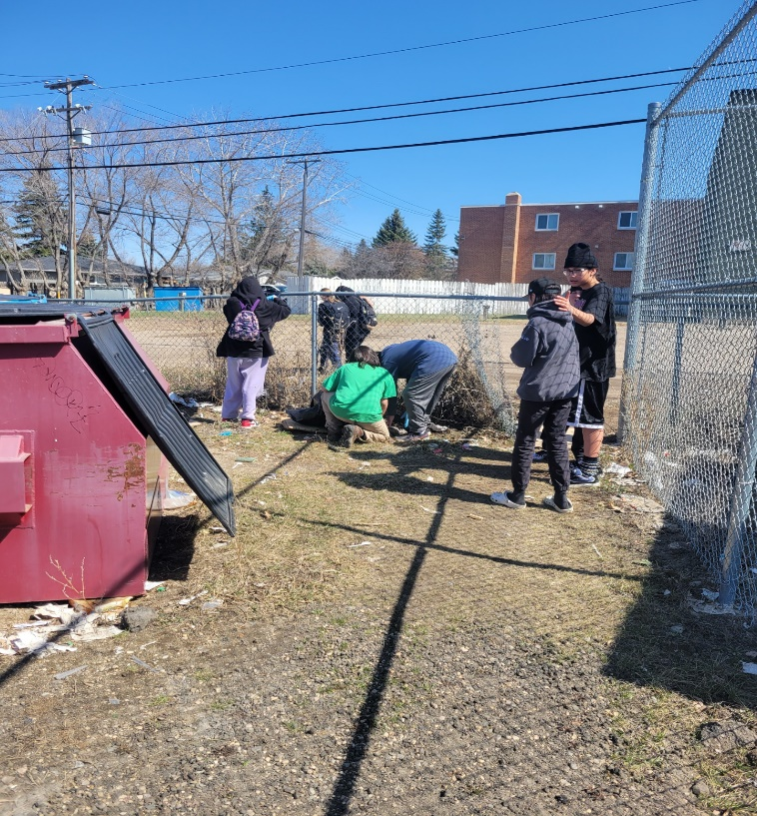

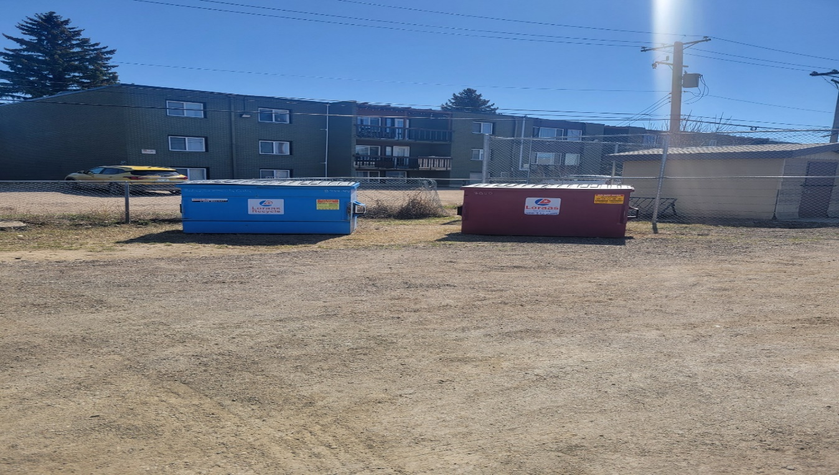

PIMIPAHTAN
PIMIPAHTAN is the long-distance running group at St. Frances (Bateman), we have 12 committed athletes who are part of the group. Students in grades 6 – 9 are immersed in clinics, workshops and training all related to long-distance running. All programming culminates in students running the 5K Youth Run at the Saskatchewan Marathon May 26, 2024. All participant registrations and fees will be covered by the school.
PIMIPAHTAN participants will make various excursions and trips throughout the year to various including the Saskatoon Track & Field House, schools and along the Meewasin trail by the river. Photo and video will be taken for archival, social media and reporting purposes.
Members of the program must maintain good attendance and grades and be ready for training until May 26. Transportation and snacks are provided.

Washroom Usage
Tansi kahkiyaw. We would like to communicate some new guidelines regarding student bathroom usage during class time. We are having some issues in our bathrooms regarding students meeting up with other students during class time, vaping, and vandalism. Our goal is to ensure there is a safe and positive environment in our school and we want to ensure students feel safe in our bathrooms. Starting immediately only one student per class will be allowed to leave the classroom at a time. Students will sign out on a sheet in the classroom and sign back in upon their return. This will allow teachers to be aware of student bathroom use and time away from class. We encourage students to use the bathroom during the bathroom breaks and the noon hour so leaving during class time is limited. If there are any medical concerns that might affect your child and their need to use the bathroom, please connect with the classroom teacher so they are aware. Thank you for your understanding and cooperation. We appreciate your help in discussing these concerns and new guidelines with your child at home to support our efforts. If you have any questions or need further information, please contact one of the administrators at the school.

Student Privacy at School Events

We’re happy that you want to take the time to attend school events and capture those precious moments with photographs or videos for personal use. When your images capture other students, care must be taken to respect their privacy.

Please do not share photographs and videos on social media that include other students unless you have permission to do so from their parents/caregivers.

Many free tools or apps are available to help you crop or edit images to blur or obscure others. Pause before you post and get permission or edit images to respect others’ privacy.

BUS/TRANSPORTATION
First Student will continue to drive students to and from school and transfer grades 6 to 9 students to St. Frances Bateman. Students provided with transportation will be expected to cooperate in a respectful and safe manner to and from school. Please call the school if you have questions regarding rules and regulations. If you are picking up your child after school and they normally take the bus home, please have a written note to give to the teacher. If you have a concern with bussing, please feel free to contact First Student directly at (306)343-2125 or late bus inquiry at (306) 343-3300. You can also use the FirstView. To download the app go to firstviewapp.com. You can also find FirstView in the App store or Google Play.
When setting up the app you will need to know the school code for St. Frances. The code for St. Frances is K8AB.

REPORTING A STUDENT ABSENCE
Using Edsby
Parents/guardians can easily submit an absence for their child using their smartphone and the Edsby app.
If you did not receive your invitation to Edsby please call the school.

NOON LUNCH
Students have the privilege of eating lunch at school when it is not possible to go home. This year we will continue to eat in our classrooms. All lunchroom expectations continue, including: remain in their classrooms during the eating portion of the lunch time, clean up after themselves, and be respectful. Supervision will be provided during the noon lunch hour. If you are dropping off lunch for your child(ren) please check in at the main office first and Joan or Sherry will call your child(ren) down to pick it up, or you can drop it off at their classroom.

STUDENT ALLERGIES
Please remember that we strive to be a nut free school. We have many students with nut allergies and want to ensure they are in a safe environment at school.

LEAVING THE SCHOOL GROUNDS AT LUNCH
For safety reasons, all students who stay for lunch are to remain on school property during the entire lunch hour. Students are not permitted to leave to go to a friend’s house or to the store during this time unless a parent/caregiver picks up their child from school to take them there. Thank you for your support and understanding. Keeping our students safe is our number one priority!

SCHOOL ZONES/PARKING
Please be reminded of the reduced speed to 30km/h in school zones every day from 7:00am to 7:00 pm. The few extra seconds can save a child from serious injury. As well, please avoid parking in the school bus or special needs (handicapped) loading zones. Vehicles in these zones will be ticketed. There are 20 busses dropping off and picking up students and arrive at the school at 8:35am and 3:00pm Monday-Friday. Thank you for your cooperation and understanding.

PROFESSIONAL LEARNING DAYS
Greater Saskatoon Catholic Schools use Professional Learning Days for elementary school staffs for staff meetings, planning, and professional development. On these days there are no students at school. Our next Professional Learning Day is Friday, May 10th.

CELL PHONE USAGE
Many students carry cell phones for safety reasons and to have communication with family while away from their care. It is school policy that all cell phones will be powered down during school hours so as not to distract from the learning atmosphere. Student will have the opportunity to use the classroom phone if needed and/or parents can leave messages for the student through the main office. If a student is not following policy, they will be asked to bring their phone to the office for the day and then pick it up before they go home. Please review this expectation with your child.

TOYS AND PERSONAL ELECTRONIC DEVICES
We encourage students to leave all toys and personal electronic devices at home. We want to create an environment free of distractions and we also know that when a child loses or belongings go missing, it creates unnecessary hardship for that child. The school does not replace items such as toys or electronic devices if they are lost or stolen. Please share this expectation with your child.

NUTRITION POSITIVE SCHOOL/NUTRITION PROGRAM
St. Frances prides itself in being a nutrition positive school. We provide breakfast, nutritious snacks, and offer a nutritional lunch to those students who need it (students are encouraged to bring a lunch, if possible, but lunch will always be available to those who need one). We are a pop and energy drink free school and discourage students from bringing any pop into the school. We appreciate your support in growing healthy children!

