2141 McPherson Ave gscs.ca 6 Bateman Crescent
306-659-7310 306-659-7940
Pre-K to Grade 5 Grades 6 to 9

Principal: Lori McAuley
Principal (Bateman): Lori McAuley
Vice Principal: Mr. Barry Kimbley
Vice Principal: Mr. Josh Klein
Office Coordinator/Secretaries: Joan Marcotte, Mrs. Sherry McEachern, Jayme Kowalchuk
School Board Trustees (Liaisons): S. Zakreski-Werbicki June 3, 2024

DATES TO REMEMBER:
May 29th Dance Troupe Wanuskewin
June 3rd PLD no school for students
June 5th Community Consultation
June 7th Oskayak powwow
June 13th GSCS powwow
June 14th St. Mary’s powwow
June 18th Grade 8 Farewell Liturgy 6:00pm (St. Francis Xavier Church)
June 21st Culture Day (Bateman)
June 21st Walk for Reconciliation (McPherson)
June 26th School Dance-McPherson 1:00-3:00pm
June 26th Progress reports sent home
June 27th Last day for students
June 28th PLD no school for students

Principal’s Message
Tansi! I know it is hard to believe but we are in our last month of school. Please send your children to school every day, there are many wonderful activities planned for the month of June and we do not want your child to miss out. Thank you, parents, and caregivers, for your support and help with your children’s learning. We are very appreciative of you and your support this year!
On behalf of our staff, I would like to wish you all a safe, healthy great summer.

2024-2025 St. Frances Cree Bilingual School Administrative Changes
Effective August, the following changes will happen:
-Barry Kimbley is moving to St. Frances McPherson as Vice-principal
-Darren Fradette is moving to St. Frances McPherson as Principal
-Dustin Kasun is moving to St. Frances Bateman as Vice-principal
-Lori McAuley is moving to St. Frances Bateman as Principal
-Josh Klein is moving to St. Angela as Principal.

Congratulations to Mr. Klein he will be moving into a Principal role and lead St. Angela School Community.

Registration Day Information
All registration information is currently available on our school website (www.gscs.ca/fra). Registration forms can be filled in online and emailed to st.frances@gscs.ca. If you cannot complete the registration forms online, then feel free to pick up a registration package anytime between 9:00am-3:00pm this week or beginning on August 29th.

tānsi kahkiyaw, YOU are invited to join our school community for a naming consultation of our new building.
Where: St. Mary’s Wellness and Education Centre at 327 Avenue N South - Parking is Free and childcare is provided until 7:30 p.m.
When: Wednesday, June 5th, 2024
Time: 4:30 p.m. –7:30 p.m.
The focus of our community consultation is to give families, students, and community an opportunity and voice in naming our new St. Frances Cree Bilingual School. As many of you know, we have been gifted a new building to educate and support our students. The expected completion of the new school is Fall of 2025, meaning we should be utilizing the new building by September of 2025.
A roast beef supper and door prizes (including a PS5, Apple Air pods, sports equipment, drone, squish mellows and much more) will be included. Draws will be made at the end of the night; you must be there to WIN!
We hope you join us for this very important evening. If you do plan on joining us, please use this QR code to register or call the school, 306-659-7310.

PIMIPAHTAN
The PIMIPAHTAN group competed in the Saskatchewan Marathon on Sunday, May 26th. We raced in the 2.2-kilometer race as the 5-kilometer race was full. Congratulations to Chayzen, Ryder, Aubree, and Araelia, they made us very proud. Congratulations to Ms. Thomas she raced a half marathon. Thank you, Mr. Peeteetuce, for supporting the Pimipahtan group. They completed the race without any problems.

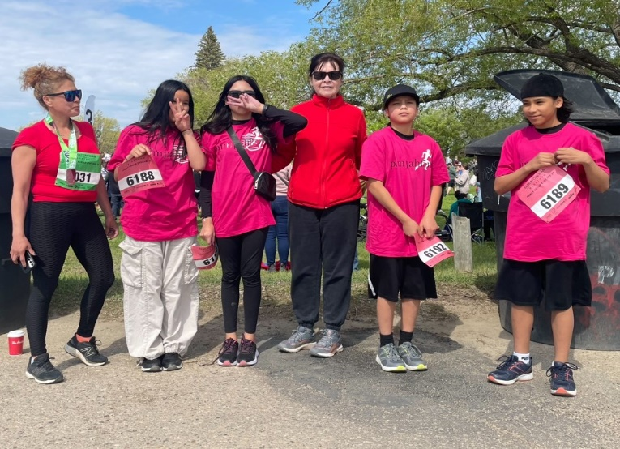

Navera Family Connections
Great news families! Navera Family Connections is now offering Rapid Access Counselling (RAC) at St. Frances School. Zack Wall is the counsellor supporting our school on Wednesdays. They offer quick access to brief mental health services for individuals, couples, and families. RAC can help with concerns such as anxiety, depression, suicidal ideation, stress, relationship conflict, separation and divorce, domestic violence, and parenting. Rapid Access Counselling provides no fee counselling when you need it. If you would like to know more or schedule an appointment, please contact our school counsellor Mrs. Scott at nscott@gscs.ca or by calling the school at 306-659-7310. We look forward to supporting your child/children!

Washroom Usage
Tansi kahkiyaw. We would like to communicate some new guidelines regarding student bathroom usage during class time. We are having some issues in our bathrooms regarding students meeting up with other students during class time, vaping, and vandalism. Our goal is to ensure there is a safe and positive environment in our school and we want to ensure students feel safe in our bathrooms. Starting immediately only one student per class will be allowed to leave the classroom at a time. Students will sign out on a sheet in the classroom and sign back in upon their return. This will allow teachers to be aware of student bathroom use and time away from class. We encourage students to use the bathroom during the bathroom breaks and the noon hour so leaving during class time is limited. If there are any medical concerns that might affect your child and their need to use the bathroom, please connect with the classroom teacher so they are aware. Thank you for your understanding and cooperation. We appreciate your help in discussing these concerns and new guidelines with your child at home to support our efforts. If you have any questions or need further information, please contact one of the administrators at the school.

Student Privacy at School Events

We’re happy that you want to take the time to attend school events and capture those precious moments with photographs or videos for personal use. When your images capture other students, care must be taken to respect their privacy.

Please do not share photographs and videos on social media that include other students unless you have permission to do so from their parents/caregivers.

Many free tools or apps are available to help you crop or edit images to blur or obscure others. Pause before you post and get permission or edit images to respect others’ privacy.

BUS/TRANSPORTATION
First Student will continue to drive students to and from school and transfer grades 6 to 9 students to St. Frances Bateman. Students provided with transportation will be expected to cooperate in a respectful and safe manner to and from school. Please call the school if you have questions regarding rules and regulations. If you are picking up your child after school and they normally take the bus home, please have a written note to give to the teacher. If you have a concern with bussing, please feel free to contact First Student directly at (306)343-2125 or late bus inquiry at (306) 343-3300. You can also use the FirstView. To download the app go to firstviewapp.com. You can also find FirstView in the App store or Google Play.
When setting up the app you will need to know the school code for St. Frances. The code for St. Frances is K8AB.

REPORTING A STUDENT ABSENCE
Using Edsby
Parents/guardians can easily submit an absence for their child using their smartphone and the Edsby app.
If you did not receive your invitation to Edsby please call the school.

NOON LUNCH
Students have the privilege of eating lunch at school when it is not possible to go home. This year we will continue to eat in our classrooms. All lunchroom expectations continue, including: remain in their classrooms during the eating portion of the lunch time, clean up after themselves, and be respectful. Supervision will be provided during the noon lunch hour. If you are dropping off lunch for your child(ren) please check in at the main office first and Joan or Sherry will call your child(ren) down to pick it up, or you can drop it off at their classroom.

STUDENT ALLERGIES
Please remember that we strive to be a nut free school. We have many students with nut allergies and want to ensure they are in a safe environment at school.

LEAVING THE SCHOOL GROUNDS AT LUNCH
For safety reasons, all students who stay for lunch are to remain on school property during the entire lunch hour. Students are not permitted to leave to go to a friend’s house or to the store during this time unless a parent/caregiver picks up their child from school to take them there. Thank you for your support and understanding. Keeping our students safe is our number one priority!

SCHOOL ZONES/PARKING
Please be reminded of the reduced speed to 30km/h in school zones every day from 7:00am to 7:00 pm. The few extra seconds can save a child from serious injury. As well, please avoid parking in the school bus or special needs (handicapped) loading zones. Vehicles in these zones will be ticketed. There are 20 busses dropping off and picking up students and arrive at the school at 8:35am and 3:00pm Monday-Friday. Thank you for your cooperation and understanding.

PROFESSIONAL LEARNING DAYS
Greater Saskatoon Catholic Schools use Professional Learning Days for elementary school staffs for staff meetings, planning, and professional development. On these days there are no students at school. Our next Professional Learning Day is Monday, March 4th.

CELL PHONE USAGE
Many students carry cell phones for safety reasons and to have communication with family while away from their care. It is school policy that all cell phones will be powered down during school hours so as not to distract from the learning atmosphere. Student will have the opportunity to use the classroom phone if needed and/or parents can leave messages for the student through the main office. If a student is not following policy, they will be asked to bring their phone to the office for the day and then pick it up before they go home. Please review this expectation with your child.

TOYS AND PERSONAL ELECTRONIC DEVICES
We encourage students to leave all toys and personal electronic devices at home. We want to create an environment free of distractions and we also know that when a child loses or belongings go missing, it creates unnecessary hardship for that child. The school does not replace items such as toys or electronic devices if they are lost or stolen. Please share this expectation with your child.

NUTRITION POSITIVE SCHOOL/NUTRITION PROGRAM
St. Frances prides itself in being a nutrition positive school. We provide breakfast, nutritious snacks, and offer a nutritional lunch to those students who need it (students are encouraged to bring a lunch, if possible, but lunch will always be available to those who need one). We are a pop and energy drink free school and discourage students from bringing any pop into the school. We appreciate your support in growing healthy children!

