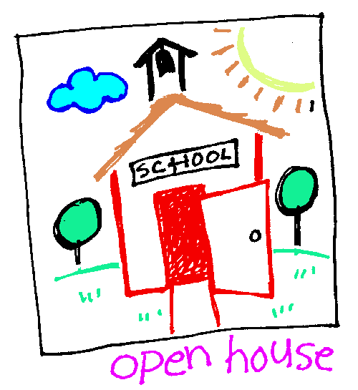

St. George Kindergarten Information Open House

Tuesday, February 27

5:15PM

Call 306-659-7320

GSCS.ca/GEO